CMP - CCNet Adaptive Management Case Study Template
Please replace <text in angle brackets> with your content.
Case Study Title: From Great Conversation to Great Conservation.
Authors: Kevin Pierson, Chief Conservation Officer, Bat Conservation International
Contact Person: Kevin Pierson, kpierson@batcon.org
Location: Portfolio is global, http://www.batcon.org/
Summary: We built replicable, scalable, models of conservation delivery while developing a shared plan for organizational development that leveraged Bat Conservation International’s structure and staffing.
Public Overview of Case Study: We did an official Report to our National Board on our Project. I have attached that document with this email. I would be happy to host that on a webpage or as a google doc.
Setting the Scene:
Bat Conservation International (BCI) staff and National Board were interested in delivering new levels of conservation impact. This included investing in projects on the ground that save bats and building replicable, scalable models of conservation delivery. BCI wanted clarity on areas of real potential for growth and a tactical plan for how to get there that leverages its new organizational structure and staffing.
To this end, BCI ran a pilot test of the Open Standards and Miradi Software in the context of BCI’s work. Specific aims of this pilot included:
- Giving BCI program staff training on the Open Standards and a one-year subscription to the Miradi Conservation Planning Desktop and Online suite of project management tools,
- Developing examples of how BCI work could be facilitated by using the Open Standards, and
- Evaluating whether this approach makes sense for BCI going forward and if so, what would be needed to roll this approach out in the organization.

We selected key Bat Conservation International (BCI) staff to participate based on both their role within the organization as well as their interests and aptitudes. We created cross-organizational working teams on specific pilot projects. We selected projects that would both represent the full gamut of BCI work and yet also provide a good training environment:
- Threat-Based Project (Wind Energy) -- This represents a thematic set of work addressing a key threat.
- Place-Based Project (Pollinating Bats in Southwestern US and Mexico) -- This project was selected to represent typical place-based projects that require a mix of strategies to deal with a set of prioritized threats to bats and their habitat.
- Global Program Template (Caverniculous Bats) -- This project was selected to represent a more generic program template that could be used to more quickly develop standardized place-based projects around the world.

The training / pilot work was designed to balance both learning about the Open Standards and doing “real” work. Given that BCI staff are not based in one office, we structured this training as a virtual exercise over the course of several months. We organized weekly web-based training sessions. At each session, one step of the Open Standards process was introduced (e.g., selecting conservation targets, rating threats, developing theories of change for conservation strategies). Staff were provided an introduction to the concepts involved in the step and then given a “homework assignment” that involved applying these concepts to BCI’s work. At the next week’s session, teams then presented and discussed the results of their homework assignment, before going on to the next step.
Results and Lessons Learned:
Rapid Transition from Training to Actual Work -- Participants found the approach and tool set to be helpful in conservation planning as evidenced by ongoing adoption following the training. As one example, following the end of the formal training, the Wind Energy Team has continued to meet regularly and uses the tools to do its planning work. In addition, participants went on to apply the methods to new and existing projects in development. As of today, BCI now has 10 active Miradi files in Miradi Share representing all major conservation strategies across the organization.
Use of OS Improves Shared Understanding of Conservation Situation -- Project team members realized that saving a specific bat species involves more than managing the specific population or roost, but instead needs to consider the wider system in which the bats are living. (See Figure 1.)
OS Materials Readily Inform Funding Proposals - Project team members developed results chains with phased timelines and objectives that became the basis for funding proposals for international species conservation work. It's rare that a project can be completed by a single funder. The results chains show the necessary steps required to get to a desired conservation result. An initial or intermediate action that needs funding may not appear as urgent or high-profile as later actions, but without the funding for all the steps, the work can’t progress and succeed. Also, some of BCI’s major funders are open standards proponents, including Disney Conservation Fund and USFWS International Programs.
Building Staff Morale with Cross-Organizational Teams - There was tremendous value in bringing staff from different program areas within the organization together to work and share knowledge in small focal teams. BCI’s program staff largely work remotely in various parts of the country and our programs have traditionally been ‘siloed’ with little interaction across programmatic areas. Sharing knowledge and expertise across the programmatic structure was a huge lift to organizational culture by improving communication, demonstrating respect for staff expertise, and identifying new opportunities for staff collaboration within the organization.
Incorporating Accountability & Rigor - The Open Standards creates a framework for measuring the impact of our conservation work. Both conceptual diagrams and results chains developed in the Open Standards can indicate where there are knowledge gaps and needs for science as they directly relate to conservation targets and action. It demonstrates the relationship between science and conservation and provides metrics for evaluating progress, which lends accountability and rigor to the work we do.

Application beyond Case:
We did this project with a relatively modest budget that was approved by our national board in advance and part of a suite of strategic investments in the organization to promote growth and impact. I think it is critical to have coaching and outside experience to facilitate a pilot like this.
We had the advantage of some internal funding and so were able to hire Foundations of Success to support out start-up phase. Given the strength of the Conservation Coaches Network and CMP there are many options for outside assistance even if an organization doesn’t happen to have funding.

Further Information:
Figure 1. (referenced in previous section) Example of Situation Analysis: Bracken Cave Preserve Conceptual Model
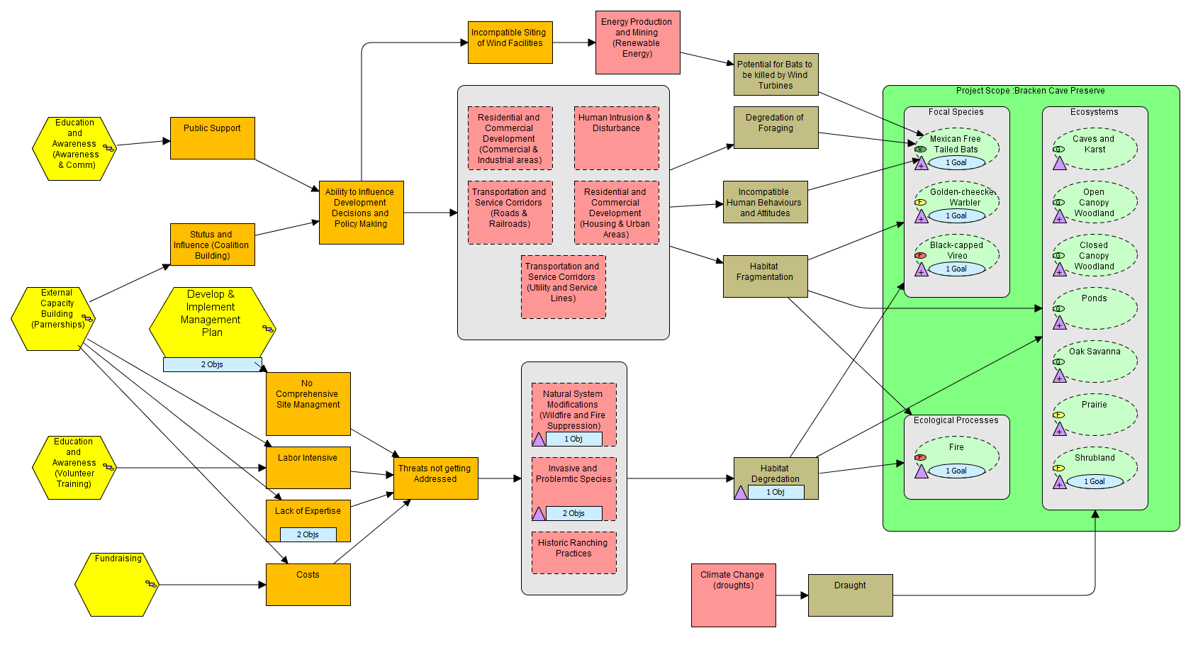

Key Words: <Please copy the following table and tick the themes that apply to your case study. This is not meant to be a restrictive list - case studies that range beyond these themes are most welcome! This table does not count against your 2-3 page limit.>

Table of Key Words for Tagging Case Studies
These tags will be used to help other people find your case study on the web.
Key Words (select all that are relevant) | Put x if Relevant
Stages in Adaptive Management Cycle
- Conceptualize the situation | X
- Plan actions and monitoring | X
- Implement actions and monitoring | X
- Analyze, use, adapt | X
- Capture and share learning | X
- Full cycle adaptive management | X
- Other__________________________
Case Study Scale
- Project-level
- Program-level
- Organizational-level | X
- Other _________________________
Specific Tools/Approach Used
- Evaluation / audit
- Evidence-based conservation
- Spatial conservation planning
- Structured decision making | X
- Status measures
- Effectiveness measures
- Passive adaptive management
- Active adaptive management | X
- Other _________________________
Specific Topics Addressed:
- Human wellbeing
- Climate change
- Community-based conservation
- Marine conservation
- Freshwater conservation
- Terrestrial conservation | X
- Other _________________________

