CMP - CCNet Adaptive Management Case Study Submission
Case Study Title:
USAID Learning Group Explores the Effectiveness of Enterprises as Conservation Strategy
Authors:
USAID E3/FAB Office and the Measuring Impact Activity, implemented by Environmental Incentives, Foundations of Success, and ICF International.

Contact Person: Megan Hill, Environment Protection Specialist, Office of Forestry and Biodiversity, USAID Bureau for Economic Growth, Education, and the Environment
mhill@usaid.gov

Location:
Global
Summary:
The USAID Office of Forestry and Biodiversity, assisted by the Measuring Impact activity, formed a learning group that brings together stakeholders from around the world, both inside and outside of USAID, to share lessons on the effectiveness of enterprises as a conservation strategy and to apply these lessons in adaptive management of conservation projects. The case study covers the initiatives under the Conservation Enterprises Learning Group and examines how using an overarching theory of change (depicted as a results chain) and associated learning questions provides a useful framework: (1) to examine the effectiveness of support for enterprises as a conservation strategy, and (2) for applying these lessons to adaptive management.
Public Overview of Case Study:
With support from Measuring Impact, USAID has developed a suite of compelling knowledge products to help members of the Conservation Enterprises Learning Group design and implement more effective programs. The Learning Group collaborates through a set of facilitated meetings, webinars, and a website (https://rmportal.net/conservation-enterprises). The website includes a wiki of lessons related to the theory of change for supporting conservation enterprises and learning questions, products developed under the learning agenda, and other resource documents related to conservation enterprises.
Measuring Impact and USAID also developed a video to share our theory-of-change approach to exploring the effectiveness of conservation enterprises for the 2015 Collaborating, Learning and Adapting Case Competition:
https://usaidlearninglab.org/lab-notes/watch-biodiversity-cross-mission-learning-program
Setting the Scene:
Over the past two decades, USAID has extensively supported conservation enterprises as a strategy for biodiversity programming. Yet, little information has been collected in a systematic way to measure outcomes and examine key assumptions regarding the effectiveness of this strategy. This group aims to gain a deeper understanding of the effectiveness of supporting conservation enterprises by exploring a set of shared learning questions focused on the theory of change. The learning questions focus not only on the outcomes in the theory of change, but on the assumptions (depicted as arrows in the theory of change). In other words, the group is not only asking “if” the strategy achieves desired results (i.e., objectives and goals), but “how” by examining the relationships between the outcomes (i.e., the assumptions) in the theory of change.
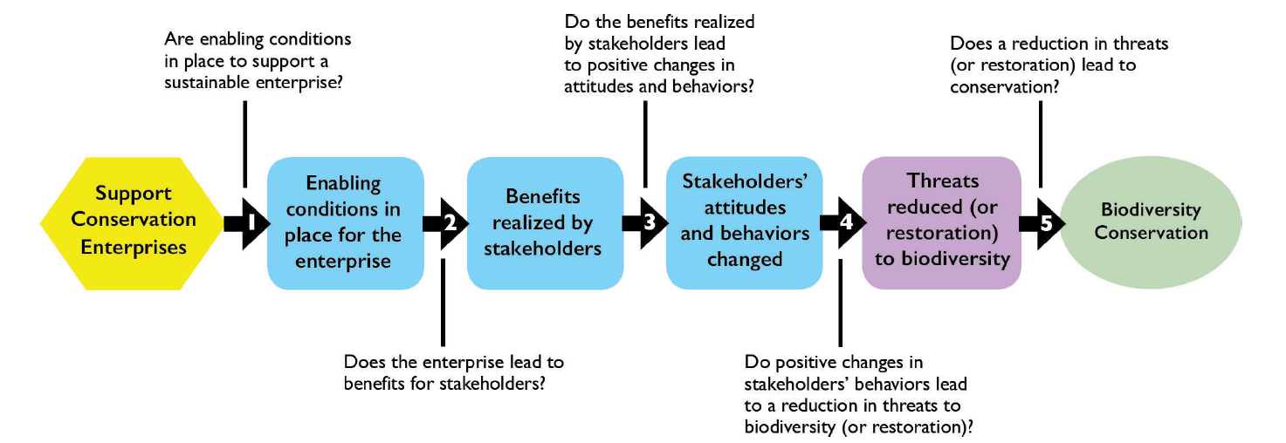
The group developed a Conservation Enterprise Learning Agenda that defines the conservation enterprise strategy, its theory of change, a set of learning questions to explore key assumptions, and activities around the following three approaches:
- synthesis: synthesize the evidence from existing documentation regarding the effectiveness of this strategy;
- retrospective: conduct a review of conservation enterprise approaches that have been in place for 20 years;
- prospective: set up monitoring, evaluation, and learning so that evidence can be generated going forward during implementation of this strategy.
Results and Lessons Learned:
To date, the learning group has implemented the first two approaches (synthesis and retrospective) to gather lessons. The learning group has shared lessons through reports, webinars, and the group's website. USAID staff, and conservation practitioners more broadly, are using these lessons to design and implement their conservation enterprise strategies. Four USAID Missions (country units) are using theory of change and lessons generated through the learning group in the design of evaluations for activities that include conservation enterprise approaches.
“The cross mission learning agenda is so important. Historically I don’t think we’ve done a great job of learning from other development partners and experiences in other countries, even from other USAID Missions. And we haven’t done a great job of building the evidence base behind which enterprises really work and under what particular circumstances. It’s refreshing to see that starting to change.” – David Chalmers, Environment Team Leader, USAID Malawi
“There are many interventions that Missions are doing around the world that are similar, why not capture those general approaches in a very common theory of change and then allow Missions to take a look at that and adapt it for their own use and tweak it in away where we can both implement them in our country and then contribute to the learning that we can do at a cross-Mission level” – Heather D’Agnes, Former Deputy Director, Environment Office, USAID Indonesia
Application beyond Case:
In helping the USAID Conservation Enterprises Learning Group develop and implement a learning agenda, we have learned that:
- the “generic” theory of change and learning questions are a useful framework for the learning group in structuring our agenda;
- examining not only “if”, but also “why” desired results are or are not achieved has led to important insights on key assumptions commonly made in implementing this strategy and the enabling conditions that support the achievement of outcomes; and
- the learning group has synthesized lessons in way that is more readily usable in designing and implementing this strategy.

This collaborative framework for learning and sharing lessons about the effectiveness of a strategy using an explicit theory of change is also being used by USAID for a set of strategies for combating wildlife trafficking, and could potentially be used for any set of strategies (e.g., each in the CMP actions classification).
Further Information: Learn more about USAID’s Conservation Enterprise Learning Group:
- Cross-Mission Learning Agenda for Conservation Enterprises
- Conservation Enterprises: Using a Theory of Change Approach to Examine Evidence for Biodiversity Conservation
- Building a Conservation Enterprise: Keys for Success
Key Words: (see below)

Table of Key Words for Tagging Case Studies
Key Words (select all that are relevant) | Put x if Relevant
Stages in Adaptive Management Cycle
- Conceptualize the situation
- Plan actions and monitoring
- Implement actions and monitoring | x
- Analyze, use, adapt | x
- Capture and share learning | x
- Full cycle adaptive management
- Other__________________________
Case Study Scale
- Project-level
- Program-level | x
- Organizational-level
- Other: Strategy-level | x
Specific Tools/Approach Used
- Evaluation / audit
- Evidence-based conservation | x
- Spatial conservation planning
- Structured decision making
- Status measures
- Effectiveness measures
- Passive adaptive management
- Active adaptive management
- Other _________________________
Specific Topics Addressed:
- Human wellbeing
- Climate change
- Community-based conservation | x
- Marine conservation
- Freshwater conservation
- Terrestrial conservation
- Other ________________________

