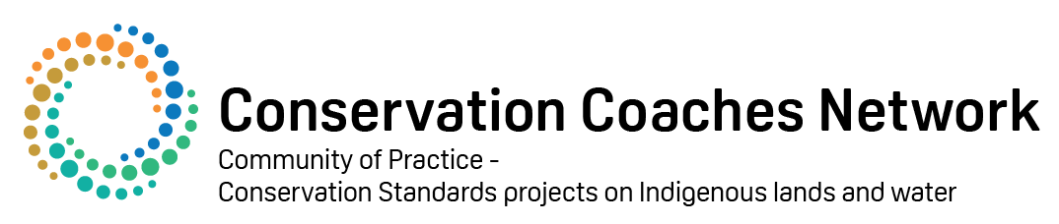
EXERCISE: Workplan and capacity
WHY WE ARE DOING THIS EXERCISE:
- To build a clear work program with a budget that is connected to the jobs that need doing, says when jobs will happen and what other support we need
- Assess overall capacity and put in place plans to access more if needed.
TASK 1 – (30 mins)
- For two strategies identified previously, complete an action plan (or work plan) based on the table below that details:
- the actions that comprise the strategy
- the person responsible for each activity
- the deadline for each activity
- and any comments that will assist with implementation
- Include the monitoring plan
Action | Responsibility | Cost / Source | Deadline | Output | Comments

TASK 2 – (30 mins)
- Consider the whole plan and carry out a capacity assessment for your team using the guidelines and table below
- Develop one Goal, Strategy and Action to address the most critical capacity ga

Project Resource  Measure | Score
 | Low | Medium | High | V High
People
Someone to lead the project
Experienced team with mix of skills
Internal Resources
Organisational support

Funding

External Resources
Social/Legal Framework

Community/Constituency Support

People
Someone to lead the project: A talented person/s with lead responsibility for the project. If there is more than one, they must have a shared vision of success and a clear way to work together.
Very High | A leader/s has (1) clearly assigned responsibility, authority, and accountability, (2) experience in doing this, and (3) sufficient time to focus on the job. If more than one leaders are involved, they have a shared vision of success and a clear way to work together.
High | A leader has any 2, but not all 3 of the above (responsibility, experience, time). If multiple leaders are involved, there may be some difficulties in collaboration.
Medium | A leader only has 1 one of the above (responsibility, experience, time). If multiple leaders are involved, they have conflicting visions of success and no collaboration mechanisms.
Low | No member(s) with designated job responsibility.

Experienced team with mix of skills: There is an experienced, multi‐skilled team to develop and implement the project available at the site.
Very High | The project receives sufficient/experienced support from a team in all the areas needed for success.
High | The project receives support from a project team – but regular support is not available in a few important areas.
Medium | The project receives some support from a project team – but regular assistance is not available in most important areas.
Low | The project receives insufficient assistance in most areas.

Internal Resources
Organisational support: An organisation is providing leadership for developing and implementing the plan. If more than one organisation is involved they have a shared vision of success and a clear way to work together.
Very High | There is clear leadership provided by one or a combination of organisations that (1) have clear responsibility and (2) adequate capacity to do the job. If more than one organisation is involved they must have a shared vision of success and a clear way to work together.
High | Organisational leadership is being provided but responsibility or capacity is not at a sufficient level. If multiple organisations are involved, there may be some difficulties in working together.
Medium | Organisational leadership is failing to provide adequate capacity even though responsibility for the plan has been accepted by one or more organisations. If multiple organisations are involved, there are serious difficulties in working together.
Low | No organisation has clear responsibility or adequate capacity to implement the plan.

Funding. Enough funding to support people and operating costs, as well as funding to implement and sustain key projects. Funding can come from many places.
Very High | Funding to implement key projects and for core operations has been secured, or is highly likely for at least two years, and the project has likely sources of long‐term funding to keep going for the next 5 years.
High | Funding to develop & launch key strategies and for core operations has been secured, or is highly likely for at least two years, and the project has done financial planning and achieved partial success in developing sources of long‐term funding to keep going for the next 5 years.
Medium | Funding has been secured or pledged for core operations and initial strategies for at least one year and some planning is underway to develop secure sources of long‐term support
Low | Funding has not been secured or pledged for core operations and strategies and no planning or implementation of long‐term funding sources.

External Resources
Social/Legal Framework: Existence of an appropriate legal tools and policy instruments that can be used to secure long term results e.g. regulations, legislation.
Very High | An appropriate framework of tools and policy instruments exists, and is either being used, or has the potential to be used at the project area.
High | Most key elements of a legal framework exist, but one key tool or policy instrument needs to be authorised or substantially amended.
Medium | Some elements of a legal framework exist, but two or more key protection tools or policy instruments need to be authorised or substantially amended.
Low | Few or no elements of a legal framework for conservation exist.

Community and Stakeholder Support: The project team effectively engages and gains the support of key stakeholders and community, including those in the local community.
Very High | The project team and their plan are favourably received and supported by the local community/ stakeholders
High | The project team and their plan are largely favourably received and supported by key stakeholders, but there is minor community resistance.
Medium | The project team and their plan have mixed support in the community and there is some community opposition.
Low | The project team and their plan have very little support in the community and there is very significant community opposition

